Cyintech
Cyintech provides AAMCORE Inc. dedicated expertise and support in technology management and deployment. Additionally, Cyintech is a recognized leader in Lead Six Sigma and BlackBelt support.
Cyintech’s focus is on process and operations improvement programs, decision support, Business Process Redesign (BPR), business process modeling, process simulation and technology support. Our clients achieve breakthrough performance through improved operations, optimized processes, and proper technology utilization.
Our Team’s Experience
- Subject matter experts with more than 35 years experience in commercial and military operations control
- Subject matter expertise with more than 40 years’ experience in fuel efficient airline operations
- Lean Six Sigma Master Black Belts and Black Belts with more than 200 successful implementations
- Technology development team skilled in the design and production of highly effective information solutions
Our Team’s Capabilities
Leveraging senior management experience from top Fortune 500 companies, standardized and customized methodologies and tools, including Lean Six Sigma and Change Acceleration Process, our approach enables clients to realize significant benefits in the areas of productivity, cost reduction, cost avoidance, risk management, force readiness, precision / velocity, program execution and customer-supplier relationship management in customized solutions
Our Services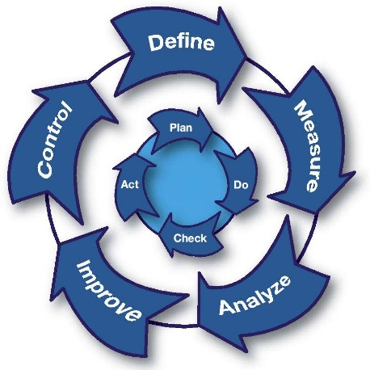
- Business Process Redesign
- Organizational Transformation
- Continuous Improvement
- Change Management / Acceleration
- Technology Requirements
- Business Automation
- Sustainment and Control

